Harlequins Challenge Match
Cricket vs Hockey
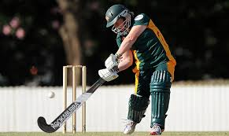

To mark the end of the cricket season and the start of the hockey season, the cricket section have challenged the hockey section to a match on Friday 25th September 2015 starting from 18:30.

- The challenge will consist of a ten over a side cricket match, followed by a 25 minute hockey match.
- Winner will be decided based on goals scored in the hockey match + net run rate of cricket match for each team.
- Losing team’s forfeit to be decided. Could potentially involve wax.
- To nominate for the Hockey section, contact Donal Holland - 0872578090, for the cricket section contact Will Doyle - 0831383387.
- The whole club is invited up to support, and the bar will be open for the evening – bring up your friends, the craic should be mighty… and potentially hairless.
- As always, volunteers to help with the smooth running of the evening will be greatly appreciated.

