Cork Harlequins Club
Club Gear Order Form 2016-2017
(Please read the form carefully before placing your Order)
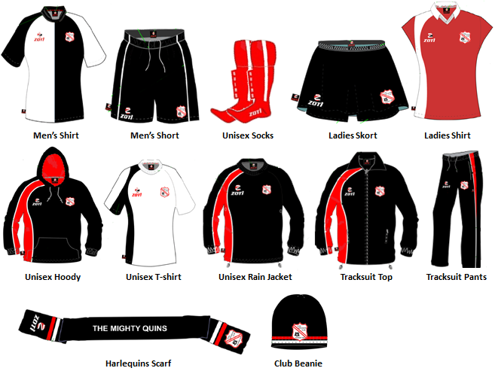

Harlequins Club - Gear Range 2016/2017
Product Code | Item | Sizes Available | Price
Z3169ZH | Ladies / Girls Home Hockey Shirt | All - See Size Charts | €25.00
Z3169ZD | Ladies / Girls Home Hockey Skort | All - See Size Charts | €30.00
Z3169C | Ladies / Girls Home Hockey Socks | S, M and L | €10.00
Z3169LKS | Ladies / Girls - Full Home Playing Strip | All - See Size Charts | €55.00
Z3169ZF | Men’s / Boys Home Hockey Shirt | All - See Size Charts | €25.00
Z3169ZG | Men’s / Boys Home Hockey Shorts | All - See Size Charts | €25.00
Z3169C | Men’s / Boys Home Hockey Socks | S, M and L | €10.00
Z3169MKS | Men’s / Boys - Full Home Playing Strip | All - See Size Charts | €50.00
Z3169ZJ | Tracksuit Top Only | All - See Size Charts | €30.00
Z3169ZK | Tracksuit Bottom Only | All - See Size Charts | €30.00
Z3169TS | Tracksuit (Top + Bottom) | All - See Size Charts | €55.00
Z3169T | Sweat Pants | All - See Size Charts | €30.00
Z3169R | Hoody | All - See Size Charts | €35.00
Z3169P | Micro Fleece | All - See Size Charts | €35.00
Z3169Q | Rain Jacket Pullover Top | All - See Size Charts | €30.00
Z3169O | Polo (Red/Black) | All - See Size Charts | €20.00
Z3169N | T-Shirt (White/Black) | All - See Size Charts | €20.00
Z3169S | Gilet | All - See Size Charts | €45.00
Z3169U | Beanie Hat | Youth / Adult | €14.00
Z3169V | Scarf | One Size Available | €16.00

To Order:
- Select the garments you would like to Order from the range listed above
- Fill out the table and be sure to indicate youth or adult sizing (Check Zoti Size Tables Below).
- E-mail your completed word document to Margret O’Neill at facilities@corkharlequins.com (preferred method) or Post to Margaret O’Neill, C/O Cork Harlequins Club, Farmers Cross, Cork.
- Once ordered Harlequins will issue you an invoice with our bank details for payment.
An order will be processed with Zoti on Monday the 12th of September, so please e-mail your completed form on or before Sunday the 11th of September. If you do not order before the 11th, the club will be making another order in January 2016. E-mail is the preferred method
Please fill out all of your contact information so that we can process your order.
Name: Mob Tel: E-mail address:
Product Code | Item | Size | Quantity | € Price
